**Radio-Carbon Dating**

* Carbon is an element that exists on Earth and is often found as carbon dioxide in the atmosphere. Most carbon atoms are an isotope (type) called Carbon-12. This type is very stable, and most Carbon atoms are this type.
* One isotope (type) of Carbon is unstable. It is called Carbon-14. Only 1 in 1012 Carbon atoms are this type.
* Both types of Carbon enter the food chain and end up in living things.
* After a living thing dies, Carbon-14 decays into Nitrogen over time but Carbon-12 remains.
* It takes **5730 years** for half of Carbon-14 in a sample to turn into nitrogen after a living thing has died.
* We can work out the age of a rock by
  + Measuring the amount of C-12 and C-14 in the sample.
  + Calculating the proportion of C-14 remaining.
  + Using a graph to work out the age of the sample.
* This type of dating is **absolute** – it is not an age relative to other fossils or rocks.
* It is able to accurately date samples that are **up to 50 000 years old**.
* The sample **must contain carbon** in order to do this dating technique – so the sample is often bone/wood/horn/antler/fire-ash or other organic matter.

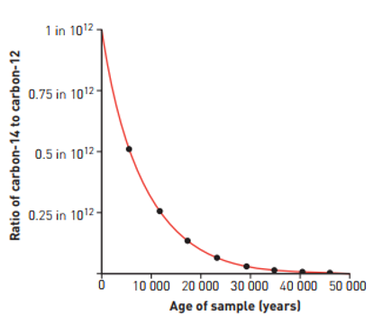

Example

A palaeontologist finds some cave paintings during exploration of an area known to be inhabited by early humans. A sample of the black paint used is shown to contain wood ash. Analysis of the ash shows that for every 1048 C-12 atoms, there is one C-14 atom. Approximately how long ago was the painting made?